Paper Plate Fans

Items Needed:
- Paper Plates
- Colouring pens / pencils
- Glue
- Jumbo craft sticks

Instructions:
- Cut a paper plate in half.

- Decorate plate however you would like

- Stick the craft sticks into a wide “V” shape to form the fan’s handle.

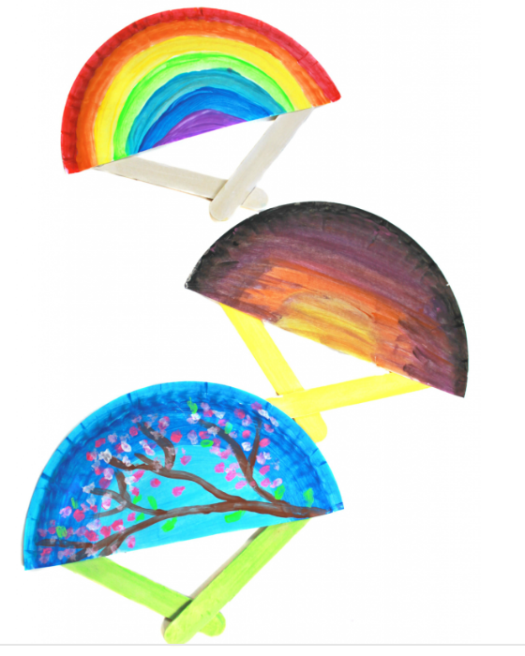
- Stick the handle to the bottom of your painted fan.

